WEDE5020
QUALIFICATION: DIPLOMA IN SOFTWARE DEVELOPMENT
PROPOSAL FOR HOUSE OF AURA LIVING

WED DEVELOPMENT POE PART 1
STUDENT NO: ST10530746
STUDENT NAME: LETLHOGONOLO RAMOKOKA
YEAR:1 GROUP: 02

Table of Contents
WEDE5020 1
WED DEVELOPMENT POE PART 1 1
1. Organisation Overview …………………………………………………………………………………3
2. Website Goals and Objectives ……………………………………………………………………….3
3. Current Website Analysis …………………………….……………………………………..………. 4
4. Proposed Website Features and Functionality…………………………………………………. 4
5. Design and User Experience …………………………………………………………….………. 4 & 5
6. Technical Requirements ……………………………………………………………………….……… 6
7. Timeline and Milestones ……………………………………………………………………………… 6
8. Budget ……………………………………………………………………………………………….……. 6
9. Site Map …………………………………………………………………………………………………….. 7
10. References …………………………………………………………………………………….…………. 9

Website Project Proposal
1. Organisation Overview
Organisation Name: House of Aura Living
Type of Organisation: Small Retail Business
GitHub Link: https://github.com/Girlhloii/WEDE2050_POE_PART1.git

BRIEF HISTORY:
House of Aura Living is a fictional small business established in 2026. The brand specializes in home fragrance products such as room sprays, reed diffusers and scented candles. The idea behind the business is to help people turn their living spaces into calm, welcoming and comfortable atmosphere through affordable quality luxury scents.
Mission Statement: To provide quality home fragrance that promote relaxation and mental well-being.
Vision Statement: To become a trusted home fragrance brand known for quality products, excellent customer service and memorable scents.
The Target Audience is students living independently, young and old adults, homeowners and individuals interested in home décor.
2. Website Goals and Objectives
The main goal of this project is to design a functional and professional website that gives House of Aura Living a proper digital home.
My specific objectives are:
- To introduce customers to the House of Aura Living.
- To showcase available products and collections.
- To provide information about the business.
- To make it easier for customers to contact the business.
- To increase brand awareness by reaching a target of 100 unique monthly visitors within the first three months of launch.

3. Current Website Analysis
House of Aura Living is a newly established business and currently does not have an official website. Customers rely on social media platforms and mouth to mouth marketing to learn about the business and its products. The absence of the website limits the business’s ability to reach a larger audience and provide detailed information about products. The proposed website will serve as the business’s primary online platform and improve its digital presence.

4. Proposed Website Features and Functionality
I plan to build a five-page website structure: (Smith, 2025)
- Home page: Introduction to the business, featured products, call to action buttons.
- About Us: Business background, Mission and Vision, Company values.
- Product Gallery: Product listing, categories, description and images.
- Service Page: Seasonal collections, new arrivals, featured fragrance collections.
- Contact/Enquiry: Contact Functional form, contact details, store Locations,
frequently asked questions, Email Address and Social Media platforms.

5. Design and User Experience
The design style will be minimalist luxury. I want the site to feel clean and peaceful.
- Colour Scheme: Ivory, Beige, White, Soft Gold, Charcoal Black.
- Typography: I’ll use a classic font for headings to feel premium and a simple clean font for body text for better readability.
- Layout: Clean and modern, easy navigation, alignment, high-quality product images, well-organized content sections.
- User Experience: User will be able to find information, browse products and contact the business easily. The design will be responsive so that it functions well on desktops, tablets and mobile devices.

- LOW-FIDELITY WIREFRAMES: (Scarano, 2021)
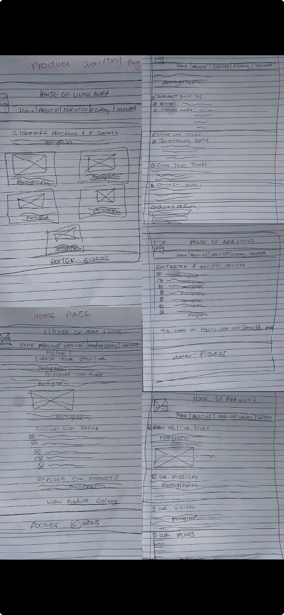

6. Technical Requirements:
The website will be developed using:
- HTML for website structure
- CSS3 for styling and layout
- JavaScript for interactive features
Development Tools:
- Visual Studio Code
- Google Chrome
- Microsoft Edge
Hosting and Domain Requirements:
- A co.za domain name
- Shared web hosting
- A stable internet connection for testing and publishing the website.
7. TimeLine and Milestones
Week 1: Research the business and gather information.
Week 2: Write the proposal and draw the wireframes.
Week 3: Create HTML pages.
Week 4: Style the website using CSS.
Week 5: Add JavaScript features.
Week 6: Test the website and fix any errors.
Week 7: Final review and submission.
8. Budget:
Budget is: R3000 for any additional items or materials.
Domain Name: R200 per year
Web Hosting: R800 per year
Images and Graphics: R0 (Free resources)
Internet and Testing: R100
TOTAL ESTIMATED COST: R1 100
9. Site Map: (Academy, 2024)
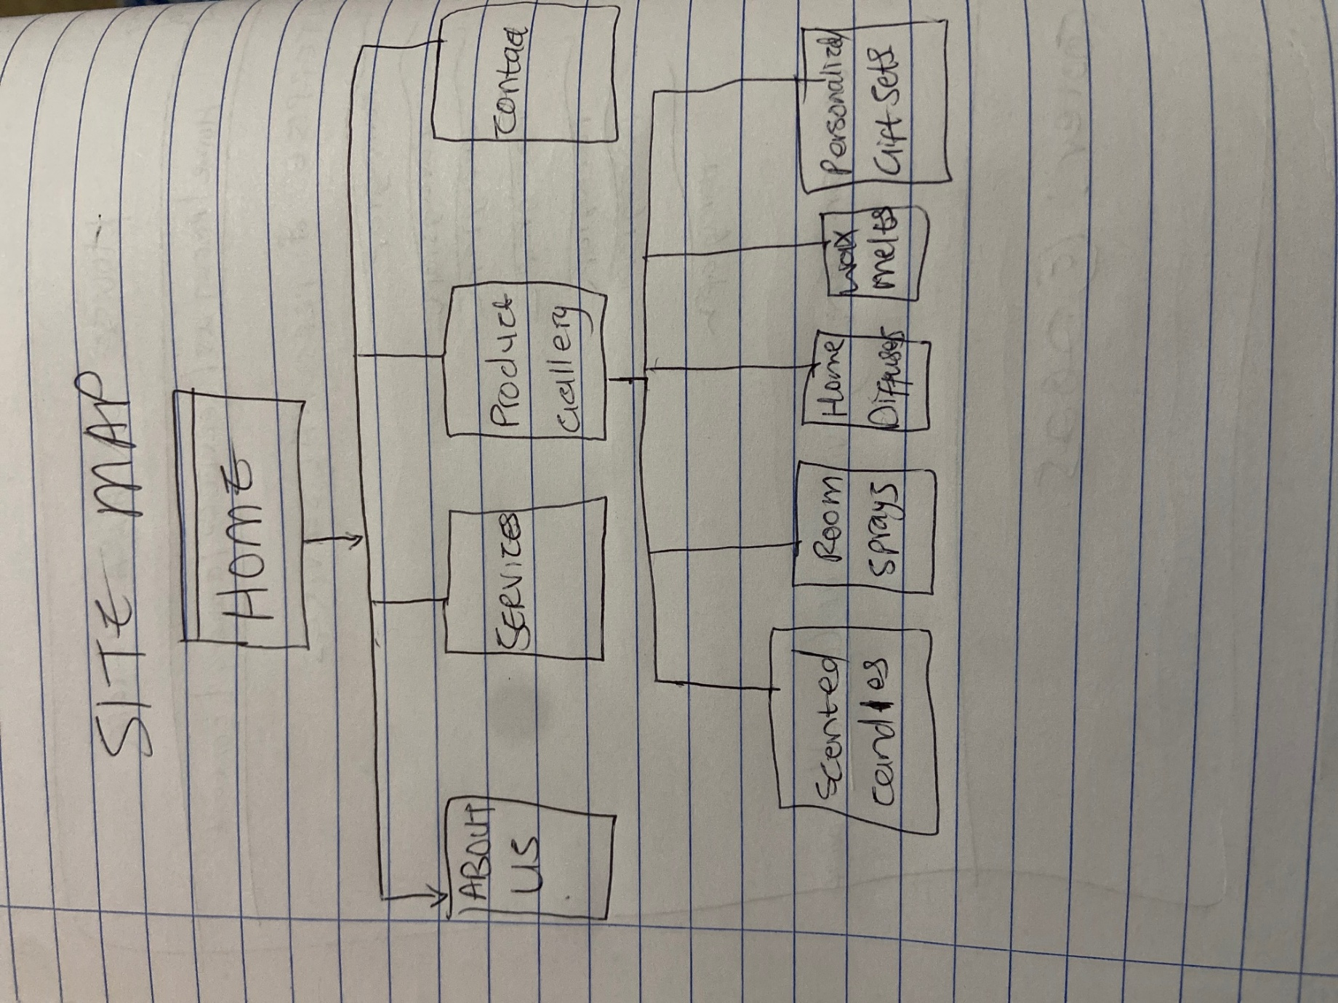

CONCLUSION:
House of Aura Living is a small fragrance business that would benefit from having a professional website. It will establish an online presence, showcase products and improve communication with customers. Using HTML, CSS and JavaScript the website will provide an attractive and user-friendly experience while supporting the business’s goals of growth and customer engagement.

10.

References
Academy, F., 2024. Flux Academy. [Online]
Available at: https://youtu.be/R_UYM9yEuYg?si=6jycDqd4T2rLhukn
[Accessed 03 August 2025].
Scarano, D., 2021. CareerFoundry. [Online]
Available at: https://youtu.be/qpH7-KFWZRI?si=OhdssvfszbTAt-cx
[Accessed 03 August 2025].
Smith, P. C., 2025. paitpro. [Online]
Available at: https://youtu.be/by8f2vYoJAE?si=TXoi-S5K14-5OgAc
[Accessed 03 August 2026].

